Lab 6 Computer Networks

Name: Tanvi Penumudy

Enroll No: E18CSE187

Batch: EB06

**CONTENTS:**

* Aim
* Procedure and Documentation
* Snapshots

**AIM**:

Virtual LAN (VLAN) Design

• Design the two networks consisting of four end devices in each network.

• Create two VLANs (with VLAN id as 100 and 200) and Rename the them as Finance and Admin departments respectively.

• Configure a VLAN (Access and Trunk ports) between two networks

• Establish communication between the end devices of the two networks

**PROCEDURE AND DOCUMENTATION:**

* The first thing is to design two networks (with any network topology) each with 4 devices on both sides.
* The network which has been chosen by me is the star network. We need to place a switch each in the middle of the PCs respectively and connect them with a straight-through wire and assign IP addresses to both the networks.
* The IP addresses that has been assigned to the first network is in the series of 192.168.1…
* Whereas the IP addresses that has been assigned to the second network is in the series of 192.168.2…
* The switch chosen is 2960-24TT switch.
* Then connect the switch to the router with gigabit ethernet 0/0 for the first network to the router and gigabit ethernet 0/1 to the second network to the router.
* Before that check whether both the individual networks are works by sending a PDUs form one PC to another in both the networks to ensure that both of the networks are working.
* Just ensure that both the networks are ready.
* Now Click on router and click on CLI a wizard will open
* Now follow the command to configure router, commands are given below:
* enable
* config t
* vlan 10
* name IT
* vlan 20
* name Finance
* interface fastethernet 0/1
* switchport made access
* switchport access vlan 10
* exit
* interface fastethernet 0/2
* switchport made access
* switchport access vlan 20
* exit
* In order to check: command- show vlan brief
* Do the following steps for both the sides of the network.
* Your vlan is now configured. Now it’s time to test.

To test select Add simple PDU and click on one computer to another computer, if you get successful message as show in figure you had successfully configured a router and connect two different networks.

**SNAPSHOTS:** 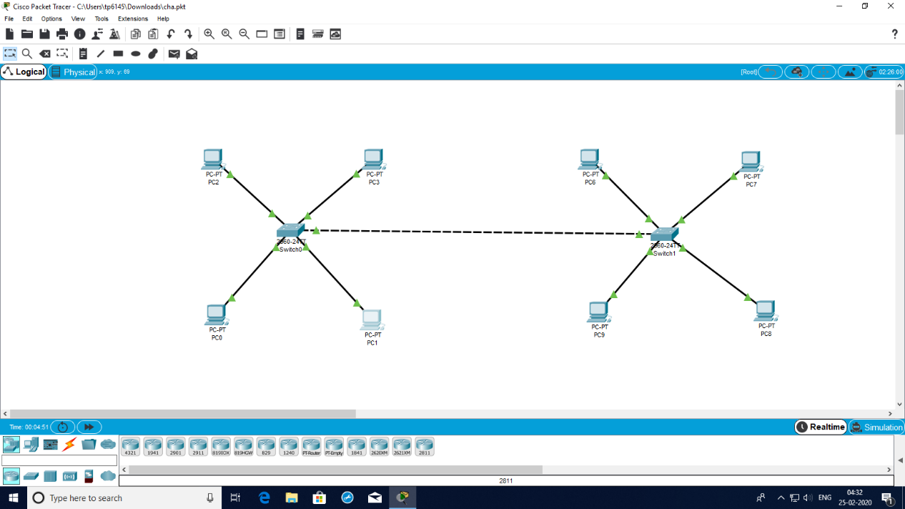

**The vlan connection between the two networks**

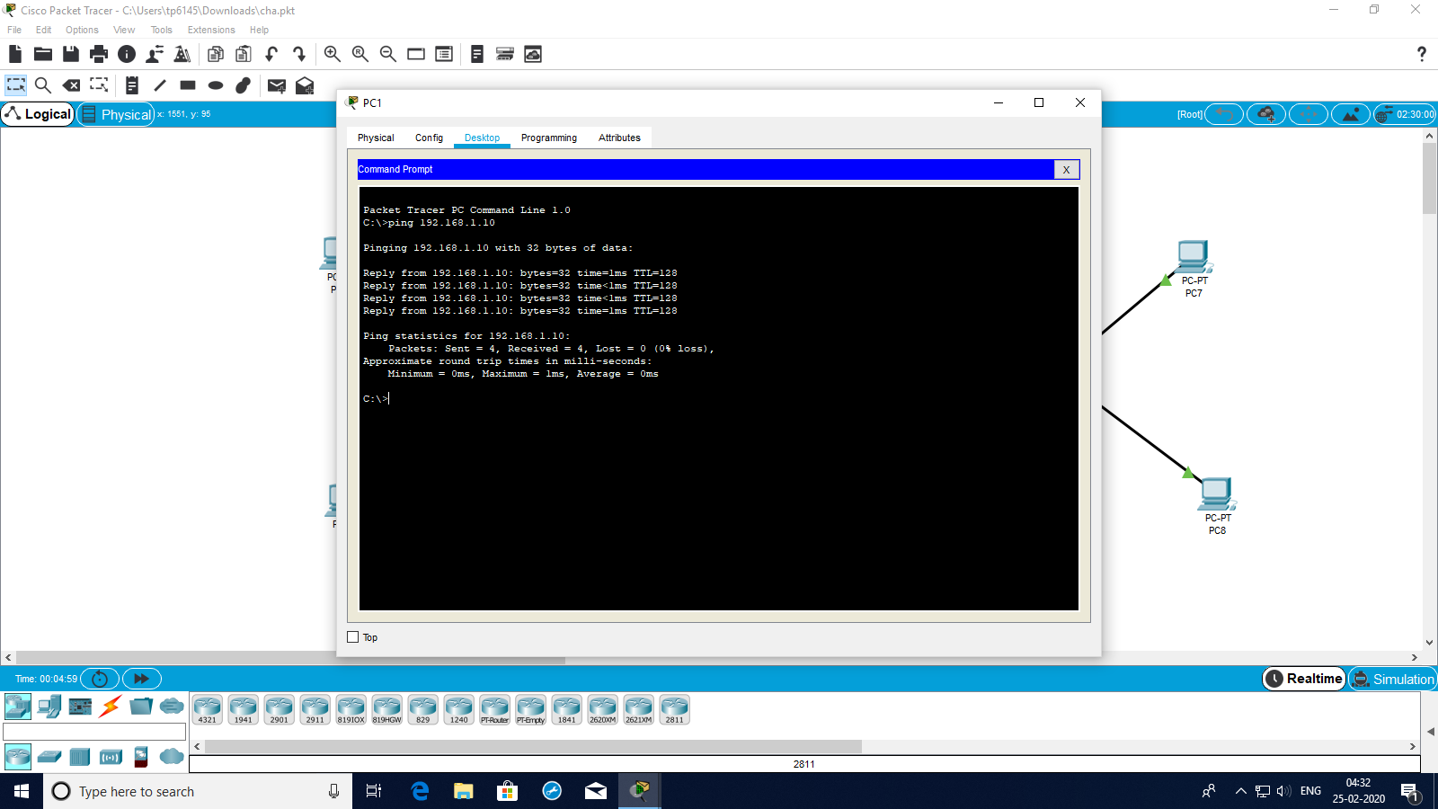

**Sending the message successfully**